# eAppendix

**eMethods 1. Detailed description of wildfire PM2.5 modelling strategy**

We measured wildfire smoke exposure by estimating daily wildfire and non-wildfire PM2.5 concentrations at the ZCTA level using a multistage approach. This approach is described in detail in Aguilera et al. 2021.

First, we estimated daily levels of PM2.5 (from any source) at the ZCTA level using a validated ensemble model combining multiple machine learning algorithms (e.g., random forest, gradient boosting) and multiple predictors (e.g., PM2.5 measurements from US EPA Air Quality System (AQS), meteorological factors such as temperature, precipitation or wind patterns, satellite-derived aerosol optical depth or land-use variables). We identified smoke-plume exposed ZCTA codes/days with the National Oceanic and Atmospheric Administration’s (NOAA) Hazard Mapping System (HMS) using a smoke binary variable by intersecting ZCTA polygons with smoke polygons. We then estimated the counterfactual PM2.5 values in the absence of wildfire smoke using spatio-temporal imputation models (relying on estimated PM2.5 on surrounding days and ZCTA). We finally estimated the difference between such counterfactual values (i.e., PM2.5 that would have been observed in the absence of the smoke event on a given ZCTA/day) to observed values of PM2.5 during an exposure to wildfire smoke. This difference between counterfactual values and observed estimated during a smoke event on a given ZCTA/day can thus be interpreted as daily/ZCTA levels of wildfire smoke PM2.5.

Said differently, after identifying ZCTA/days exposed to wildfire smoke (yes/no, using HMS products), we imputed the level of PM2.5 that would have been observed in the absence of the smoke event on a given ZCTA/day and then compared this *counterfactual* value to what has been actually observed in such ZCTA/days to obtain wildfire smoke PM2.5. This ensemble model achieved high accuracy with R2 of 0.86 and RMSE of 3.48 (Aguilera et al., 2021).

## eMethods 2. Notes on wildfire evacuation zones, boundaries, and exposure definition

We obtained shapefiles of the Woolsey and Getty fire boundaries from <https://frap.fire.ca.gov/mapping/gis-data/>. These files describe boundaries around all areas burned by the fires. In reality, the fire boundaries were smaller at the beginning of the fires, and expanded as they burned. We used these static boundaries to identify exposed ZCTAs.

The Woolsey fire, in particular, burned for 13 days. Therefore, ZCTAs that were close to the fire boundary and defined as ‘exposed’ in our study may not have been proximal to the fire at first, and may not have been truly exposed until later. Unfortunately, fire boundaries were not recorded early in either fire, so data describing the smaller boundaries isn’t available. Boundaries that are available are here: <https://data-nifc.opendata.arcgis.com/search?tags=Category%2Chistoric_wildlandfire_opendata>.

Just as the fire boundaries changed, evacuation zones also changed throughout each fire. GIS evacuation zone data was not available for either fire, though there were several maps available of evacuation zones at different points during each fire. We reviewed the following webpages containing maps of the evacuation zones, and traced what we believed to be an accurate boundary around all areas evacuated in each fire in QGIS.42 The evacuation zone boundaries we defined are plotted in Figure 1 in the main manuscript, along with the fire boundaries.

Notably, The Thomas Fire also burned over 1100 km2 during our study period40. However, most of the fire burned in the rural northern corner of Ventura County and outside the study area. Therefore, we did not include the Thomas Fire in the proximity analyses, since very few participants would have been exposed to it. Still, smoke from this fire contributed substantially to wildfire PM2.5 in Ventura County in December 2017, and therefore was included in our PM2.5 analyses (Figure 2b in the main manuscript).

Our code is available at <https://github.com/heathermcb/kaiser_wildfires>.

| Getty fire: |
| --- |
| 1. <https://www.newsweek.com/getty-fire-evacuation-map-update-california-los-angeles-1468222> |
| 1. <https://www.newsweek.com/getty-center-fire-map-evacuation-los-angeles-california-1468100> |
| 1. <https://www.express.co.uk/news/world/1196943/getty-fire-evacuation-map-405-fire-update-los-angeles-fire-evacuation-road-school-closures> |
| 1. <https://www.flyertalk.com/forum/los-angeles/1993097-getty-fire-405-closed-sepulveda-pass-now-open.html> |
| 1. <https://heavy.com/news/2019/10/getty-fire-los-angeles/> |

| Woolsey fire: |
| --- |
| 1. <https://www.kclu.org/local-news/2018-11-10/map-shows-boundaries-of-woolsey-hill-brush-fires-and-evacuation-areas> |
| 1. <https://wildfiretoday.com/tag/woolsey-fire/> |
| 1. <https://www.dailynews.com/2018/11/08/this-map-shows-where-the-hill-fire-and-woolsey-fire-are-burning/> |
| 1. <https://www.mercurynews.com/2018/11/09/map-of-woolsey-and-hill-fires-highway-101-closed-malibu-evacuated/> |
| 1. <https://woolseylawyers.com/woolsey-fire-map/> |

## eMethods 3. Higher-level groupings of ZCTAs

We created higher-level groupings of ZCTAs using the numerical ZCTA codes. We used a bespoke method, and then tested the resulting spatial groupings to make sure that ZCTAs grouped together had similar exposure measurements, to guard against exposure misclassification. We grouped ZCTAs together if all their numerical codes differed by 1 in sequence. For example, codes 90001-90008 and 90011-90014 were in the study area. We grouped codes 90001 - 90008 together, as they are all sequentially 1 digit apart, while 90011-90014 formed a second grouping. This method resulted in groupings of ZCTAs that were all adjacent, since similar codes tend to be geographically close.

Using this method, we created 274 groups containing 1-19 ZCTAs each, with a mean and mode group size of 2. We assessed the correlation between wildfire PM2.5 within each group and between all ZCTAs regardless of group, concluding that wildfire PM2.5 measurements within groups were highly correlated (mean within-group correlation was r = 0.96), while mean correlation of PM2.5 between any two ZCTAs was 0.48. We also mapped the groups to confirm that all ZCTAs grouped together were adjacent. The code that creates these groupings and assesses them is available at <https://github.com/heathermcb/wildfires_and_DME.>

## eFigure 1. Parallel trends assumption

The following are plots of mean weekly visits of each type throughout the study period. Red lines represent mean visits in areas exposed to the Getty Fire and Woolsey Fire respectively, while black lines are respective unexposed areas. We concluded that the parallel trends assumption held in all cases.



**eFigure 2. Example map of residuals from spatial autocorrelation test**



Moran’s I stat for this test was = 0.03, with a p-value of 0.077.

**eFigure 3. DAG describing hypothesized relationship between exposure to nearby wildfires and health visits**

The following DAG describes the mixed exposure we want to capture by isolating people living <20km from a wildfire, or <10km from an evacuation zone.

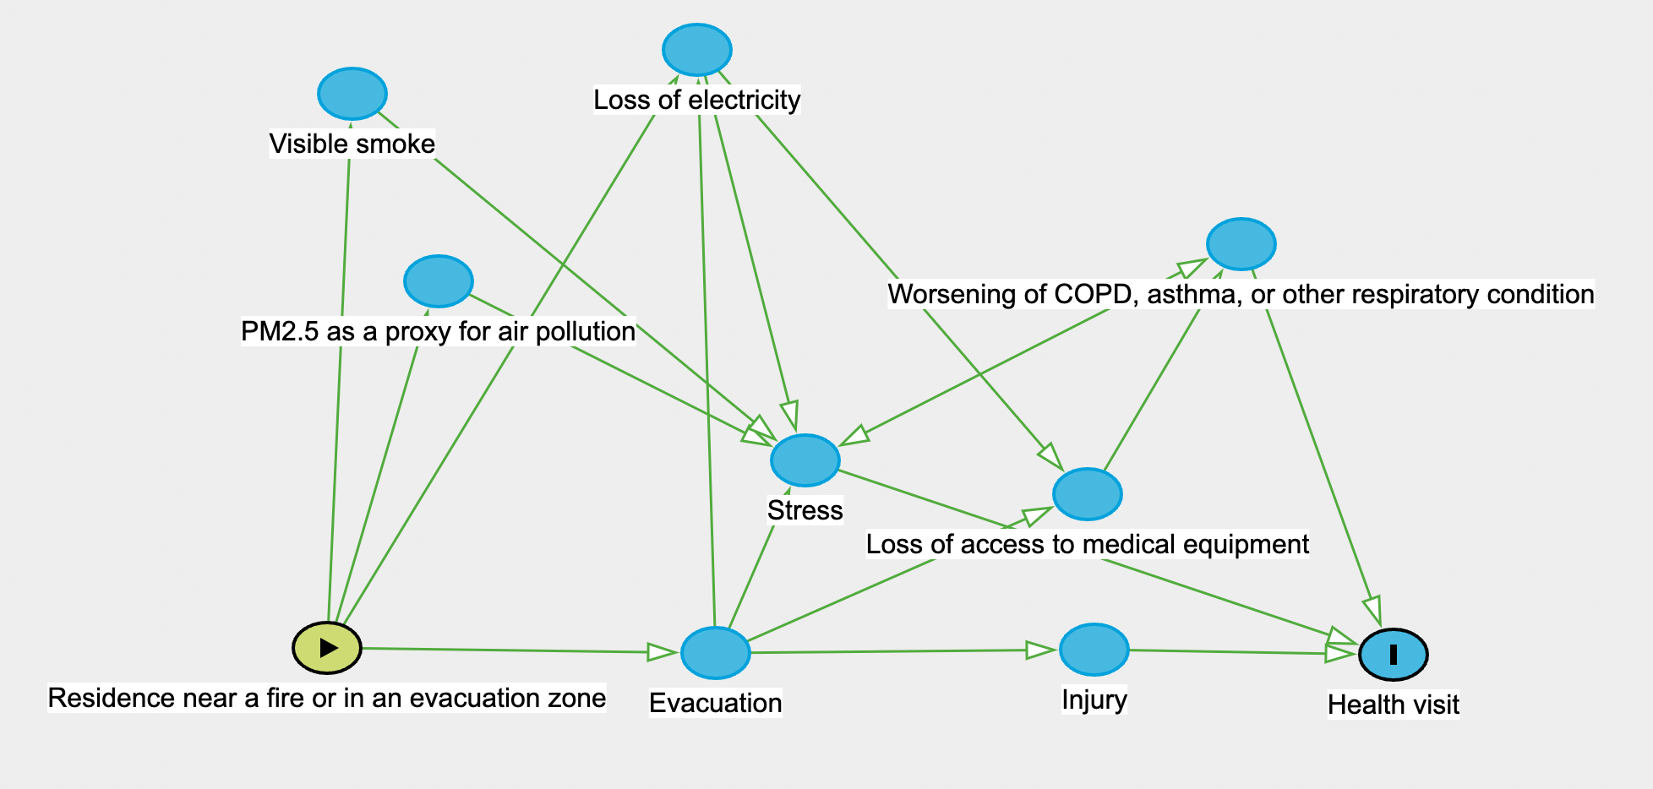

**eTable 1a. Results of the difference-in-differences (DID) models of the effect of Woolsey proximity during an active fire on healthcare visits among KPSC DME renters.** The DID estimators subtracted the change in visit frequency when the Woolsey Fire was burning versus not burning among control ZCTAs (difference 1) from the change in visit frequency when the Woolsey Fire was burning versus not burning among ZCTAs exposed to the fire (difference 2). Exposed ZCTAs were those within 20km of the fire boundary and control ZCTAs were those 20km that has not been exposed to a major fire earlier in the study period. The sensitivity analysis presented used a 30km buffer distance. Negative binomial models were controlled for time effects, temperature, and non-wildfire PM2.5, with an offset for the size of the exposed population.

| **Risk ratio for exposure to fire during fire (DID estimator), [95% confidence interval]** | | |
| --- | --- | --- |
| **Outcome** | **Woolsey Fire** | **Woolsey Fire sensitivity – 30 km buffer** | |
| All-cause outpatient | 0.89 [0.79, 1.00] | 0.89 [0.78, 1.02] | |
| All-cause inpatient | 1.35 [0.93, 1.96] | 1.29 [0.85, 1.96] | |
| All-cause ED | 1.13 [0.85, 1.49] | 1.29 [0.85, 1.96] | |
| Inpatient: cardiorespiratory concerns | 1.45 [0.99, 2.12] | 1.40 [0.91, 2.15] | |
| ED: cardiorespiratory concerns | 1.07 [0.78, 1.45] | 1.07 [0.75, 1.52] | |

**eTable 1b. Results of the difference-in-differences (DID) models of the effect of Getty proximity during an active fire on healthcare visits among KPSC DME renters.** The DID estimators subtracted the change in visit frequency when the Getty Fire was burning versus not burning among control ZCTAs (difference 1) from the change in visit frequency when the Getty Fire was burning versus not burning among ZCTAs exposed to the fire (difference 2). Exposed ZCTAs were those within 20km of the fire boundary and control ZCTAs were those 20km that has not been exposed to a major fire earlier in the study period. The sensitivity analysis presented used a 30km buffer distance. Negative binomial models were controlled for time effects, temperature, and non-wildfire PM2.5, with an offset for the size of the exposed population.

| **Risk ratio for exposure to fire during fire (DID estimator), [95% confidence interval]** | | |
| --- | --- | --- |
| **Outcome** | **Getty Fire** | **Getty Fire – 30 km buffer** | |
| All-cause outpatient | 1.02 [0.93, 1.13] | 0.97 [0.86, 1.09] | |
| All-cause inpatient | 0.93 [0.60, 1.45] | 0.78 [0.45, 1.36] | |
| All-cause ED | 0.97 [0.73, 1.27] | 0.78 [0.55, 1.09] | |
| Inpatient: cardiorespiratory concerns | 0.96 [0.61, 1.50] | 0.77 [0.43, 1.37] | |
| ED: cardiorespiratory concerns | 0.92 [0.67, 1.26] | 0.74 [0.50, 1.09] | |

**eTable 1c. Results of the difference-in-differences (DID) models of the effect of Woolsey evacuation exposure during an active fire on healthcare visits among KPSC DME renters.** The DID estimators subtracted the change in visit frequency when Woolsey Fire was burning versus not burning among control ZCTAs (difference 1) from the change in visit frequency when the Woolsey Fire was burning versus not burning among ZCTAs exposed to evacuation zone (difference 2). Exposed ZCTAs were those within 10km of the evacuation boundary and control ZCTAs were those 10km from the evacuation boundary that had not been exposed to a major fire earlier in the study period. The sensitivity analysis presented used a 30km buffer distance. Negative binomial models were controlled for time effects, temperature, and non-wildfire PM2.5, with an offset for the size of the exposed population.

| **Risk ratio for exposure to evacuation during fire (DID estimator), [95% confidence interval]** | | |
| --- | --- | --- |
| **Outcome** | **Woolsey Fire** | **Woolsey Fire – 30 km buffer** | |
| All-cause outpatient | 0.86 [0.72, 1.03] | 0.88 [0.78, 1.00] | |
| All-cause inpatient | 1.53 [0.90, 2.62] | 1.22 [0.82, 1.82] | |
| All-cause ED | 1.18 [0.78, 1.80] | 1.05 [0.77, 1.44] | |
| Inpatient: cardiorespiratory concerns | 1.72 [1.00, 2.96] | 1.30 [0.86, 1.95] | |
| ED: cardiorespiratory concerns | 1.13 [0.72, 1.78] | 1.00 [0.71, 1.40] | |

**eTable 1d. Results of the difference-in-differences (DID) models of the effect of Getty evacuation exposure during an active fire on healthcare visits among KPSC DME renters.** The DID estimators subtracted the change in visit frequency when Getty Fire was burning versus not burning among control ZCTAs (difference 1) from the change in visit frequency when the Getty Fire was burning versus not burning among ZCTAs exposed to evacuation zone (difference 2). Exposed ZCTAs were those within 10km of the evacuation boundary and control ZCTAs were those 10km from the evacuation boundary that had not been exposed to a major fire earlier in the study period. The sensitivity analysis presented used a 30km buffer distance. Negative binomial models were controlled for time effects, temperature, and non-wildfire PM2.5, with an offset for the size of the exposed population.

| **Risk ratio for exposure to evacuation during fire (DID estimator), [95% confidence interval]** | | |
| --- | --- | --- |
| **Outcome** | **Getty Fire** | **Getty Fire – 30 km buffer** | |
| All-cause outpatient | 0.88 [0.69, 1.12] | 1.03 [0.93, 1.15] | |
| All-cause inpatient | 0.19 [0.02, 1.60] | 0.94 [0.61, 1.46] | |
| All-cause ED | 0.65 [0.30, 1.42] | 1.03 [0.78, 1.36] | |
| Inpatient: cardiorespiratory concerns | 0.21 [0.02, 1.73] | 0.86 [0.54, 1.37] | |
| ED: cardiorespiratory concerns | 0.66 [0.27, 1.62] | 1.03 [0.76, 1.41] | |